Exhibit 1. F Worksheet in Alphabetical Testing Loop

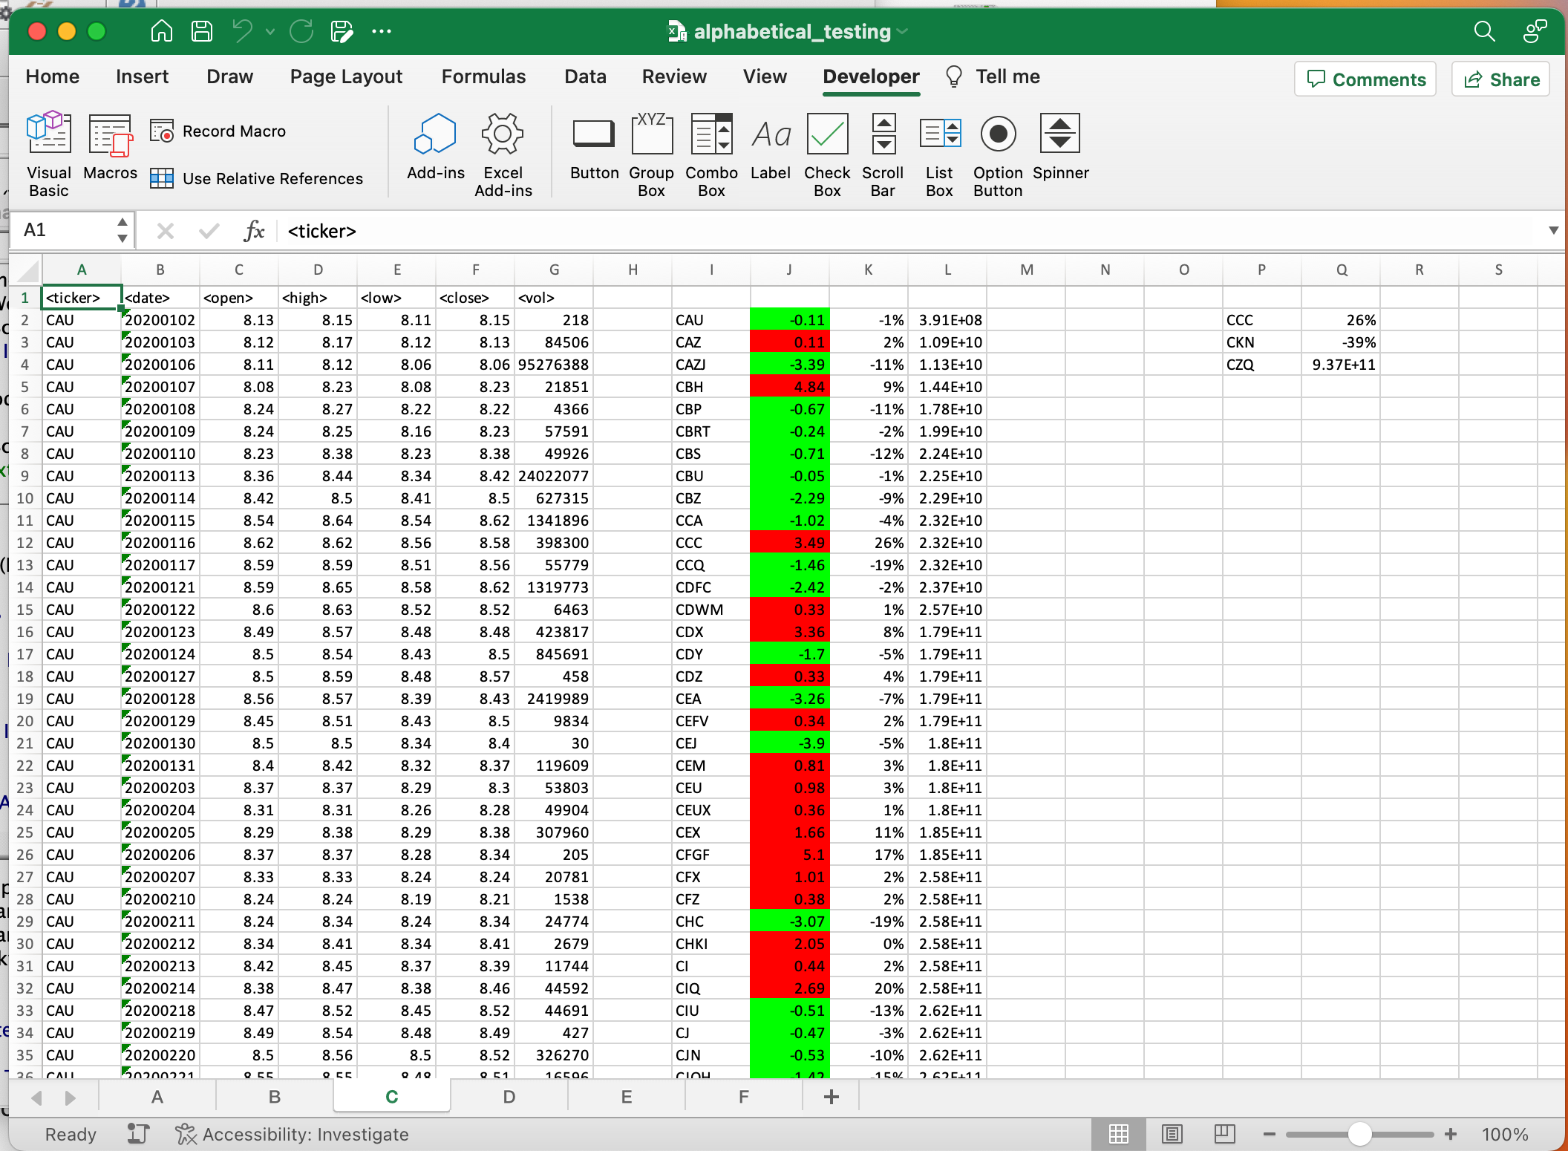

Exhibit 2. C Work Sheet in Alphabetical Testing Loop